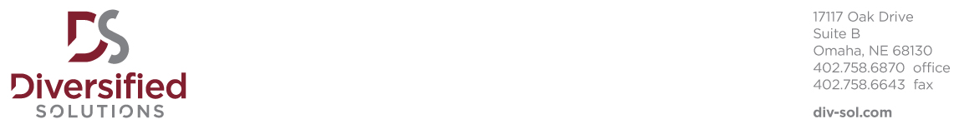

Right to Represent Acknowledgment

Diversified Solutions has explained that there may be opportunities in which I am qualified for at the following companies, I therefore give Diversified Solutions my exclusive authorization to represent me to the following clients:

Mutual of Omaha

Additionally, I agree that I will not permit or authorize any other company or individual to submit me as a candidate for an assignment to the above-named clients and I confirm that I have not authorized verbally or in writing, anyone other than Diversified Solutions to submit me as a candidate to the above-named clients.

This exclusive agreement will remain in effect for ninety (90) days.

I understand this is not an offer or contract of employment.

____________________________________
Candidate Signature

___________________________________
Date

